**1. *Counting heads*. Given integers *n* and *k*, along with , you want to determine the probability of obtaining exactly *k* heads when *n* biased coins are tossed independently at random, where *pi* is the probability that the *i*th coin comes up heads. Give an *O*(*n*2) dynamic programming algorithm for this task. Assume you can multiply and add two numbers in [0,1] in *O*(1) time.**

**Answer:**

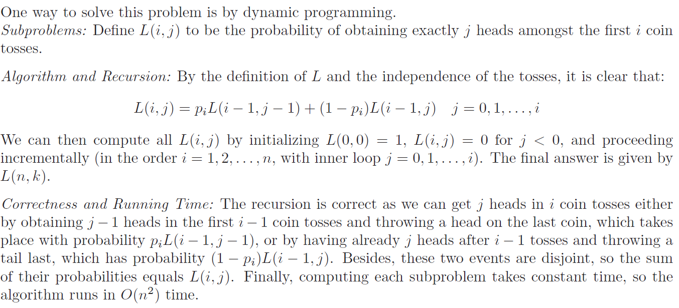

**2. Given two strings and, we wish to find the length of their longest common substring, that is, the largest *k* for which there are indices *i* and *j* with  .**

**(1) Give a dynamic programming algorithm to do this in time *O*(*mn*). (Hint: define subproblem *L*(*i*, *j*) to be the length of the longest common substring of *x* and *y* terminating at *xi* and *yj*)**

**(2) Suppose that x=ABCBDAB and y=BDCABA. Fill the following table showing all intermediate optimal values  defined above.**

|  |  |  |  |  |  |  |  |  |
| --- | --- | --- | --- | --- | --- | --- | --- | --- |
| ***L*(*i*, *j*)** |  | **A** | **B** | **C** | **B** | **D** | **A** | **B** |
|  |  |  |  |  |  |  |  |  |
| **B** |  |  |  |  |  |  |  |  |
| **D** |  |  |  |  |  |  |  |  |
| **C** |  |  |  |  |  |  |  |  |
| **A** |  |  |  |  |  |  |  |  |
| **B** |  |  |  |  |  |  |  |  |
| **A** |  |  |  |  |  |  |  |  |

**Answer:**

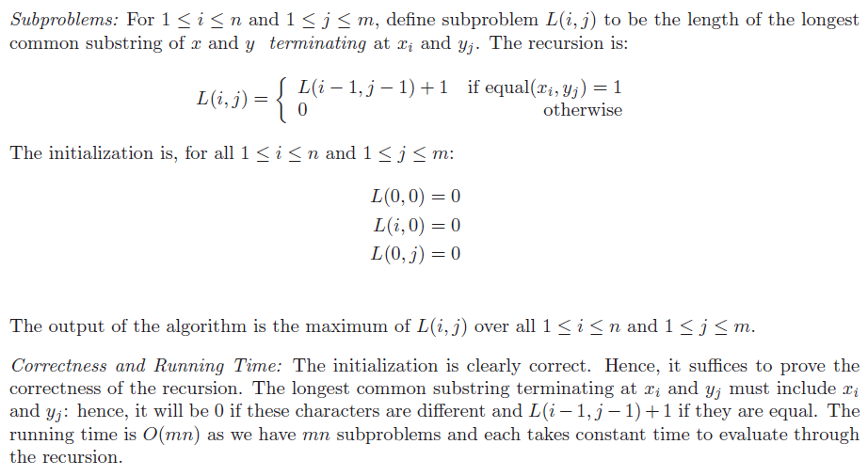**(1)**

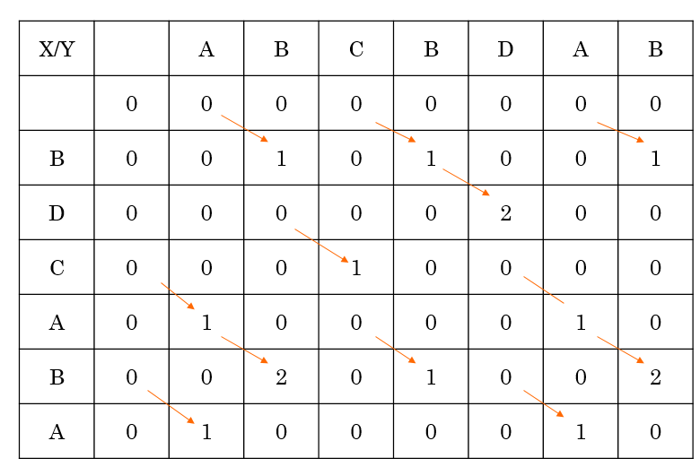**(2)**

**3. Given a data structure *D* that supports Sequence operations:**

* ***D*.build(*X*) in *O*(*n*) time, and**
* ***D*.insert_at(*i*, *x*) and *D*.delete_at(*i*), each in *O*(log *n*) time,**

**where *n* is the number of items stored in *D* at the time of the operation, describe algorithms to implement the following higher-level operation *reverse*(*D*, *i*, *k*) in terms of the provided lower-level operations.**

**Recall, delete_at returns the deleted item.**

***reverse*(*D*, *i*, *k*): Reverse in *D* the order of the *k* items starting at index *i* (up to index *i* + *k* − 1). The operation should run in *O*(*k*log*n*) time.**

**Answer:**

